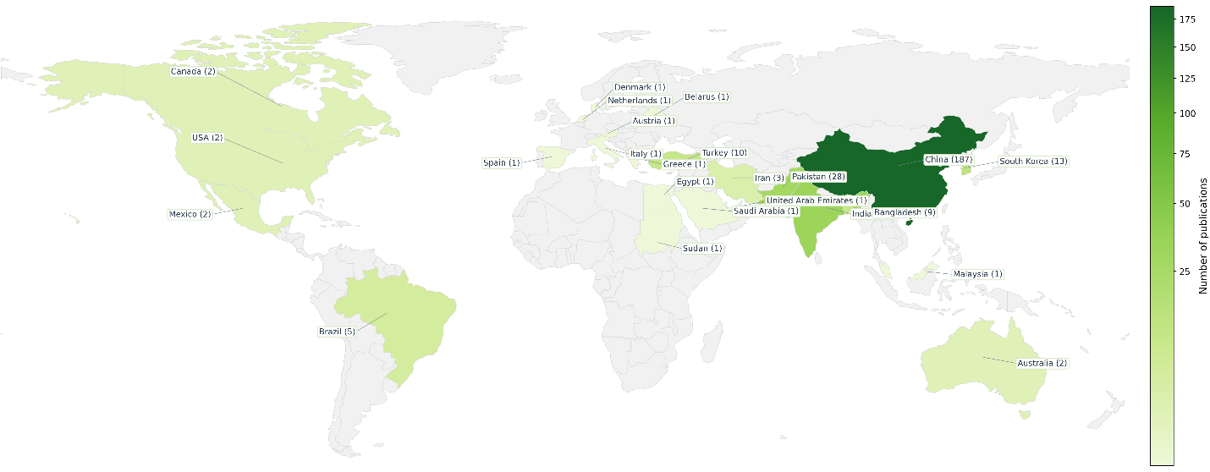
Figure 2. Country-wise distribution of studies included in meta-analysis. The world map shows the number of research papers that each country has produced. The color grading indicates the number of publications.

